**Logging Error and Warning Messages Using SLF4J**

To implement a basic logging system in a Java application using the **SLF4J API** and the **Logback** backend. The application logs messages at different severity levels, specifically error and warn.

**Tools & Technologies Used:**

| **Tool/Library** | **Purpose** |
| --- | --- |
| **Java (JDK 19)** | Programming language |
| **Maven** | Build and dependency management |
| **SLF4J (v1.7.30)** | Logging API |
| **Logback (v1.2.3)** | SLF4J-compatible logging backend |
| **IntelliJ IDEA** | IDE used for development |

**Implementation Steps:**

**Step 1: Created Maven Java Project**

* Project name: SLF4JLogger_exercise
* IDE: IntelliJ IDEA (New Maven Project)
* JDK version: 19

**Step 2: Added Dependencies in pom.xml**

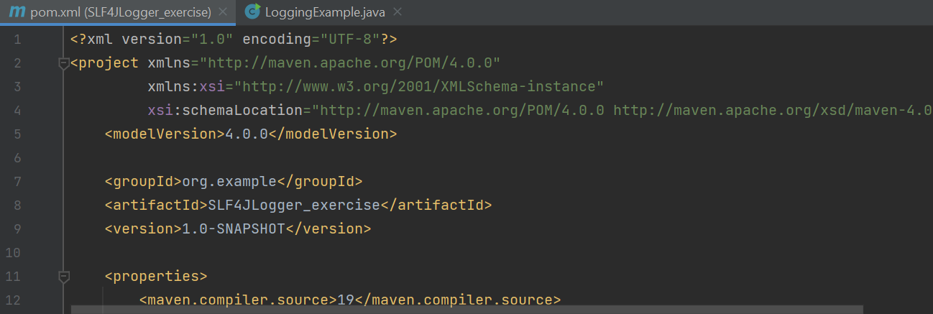

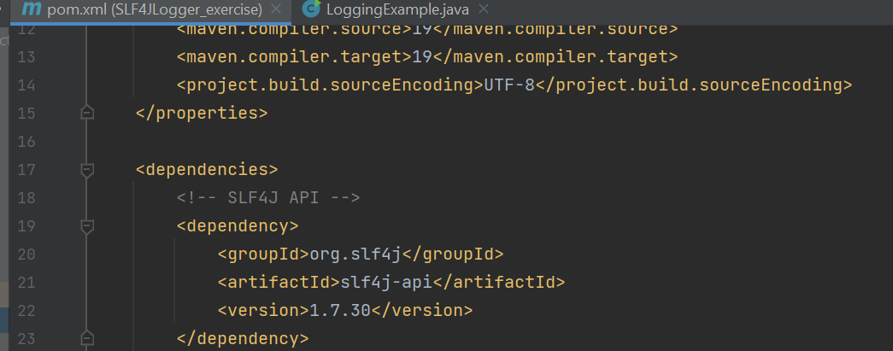

**Step 3: Created the Java Logger Class**

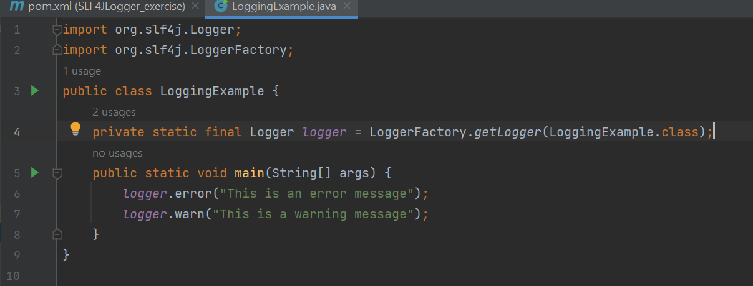

**Step 4: Ran the Application**

**Output:**

